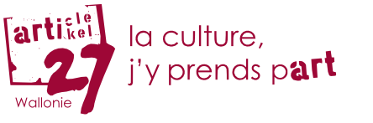

"Everyone has the right freely to participate in the cultural life of the community, to enjoy the arts and to share in scientific advancement and its benefits."
Article 27 of the Universal Declaration of Human Rights

Unfortunately, it is often difficult for many people to participate in cultural events due to financial or other reasons.

Therefore, Asbl Article 27 has made it its mission to facilitate access to cultural life for these people.

In the south of the DG, Article 27 is introduced through a cooperation between
- the PSWCs of Saint Vith, Amel and Burg-Reuland,
- the Patchwork VoG,
- and the cultural partner organizations AGORA Theater, ArsVitha, East Belgium Festival and Kino Scala.

The offer is addressed to all persons who are regular clients of the various social services in the 3 Eifel municipalities of Sankt Vith, Amel and Burg-Reuland.

Contact: Patchwork VoG
Bleichstraße 8,4780 Sankt Vith
info@patchwork-vog.be
080 330 411 or 0472 72 23 00 https://article27.be
Opening hours: Mon-Thu 10:00-12:30
13:30-16:30

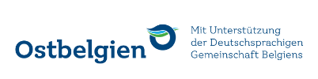
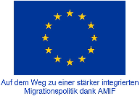



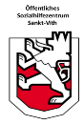
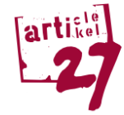
So funktionniert es:
The PSWCs take over the financing and order from asbl article 27 tickets at a price of € 5 each.

At your SOCIAL SERVICE (PSWC, etc.) you will receive a certificate.




With this document you will receive an Article 27 ticket at PATCHWORK.
Each person has the possibility to get one ticket per month.
The cultural partner sends the redeemed ARTICLE 27 tickets back to the ASBL ARTICLE 27 in exchange for the 5 Euro proceeds.

f
Choose an event in the CULTURAL PARTNERS programs and receive a ticket in exchange for an Article 27 ticket and €1.25.
There are 2 possibilities:
- You reserve your seat yourself.
- You register for an organized group visit to an event.



Enjoy a nice moment in the theater, concert hall, cinema or museum!

